Project Design Phase-II
Technology Stack (Architecture & Stack)
Date | 30 September 2026
Team ID | SWUID2026286057
Project Name | Implement Client Script & UI Policy (Incident)
Maximum Marks | 4 Marks
Technical Architecture:
The deliverable includes the architectural diagram below and the information as per Table-1 and Table-2.
Example: Dynamic field control and validation on the ServiceNow Incident form
Reference: https://developer.servicenow.com
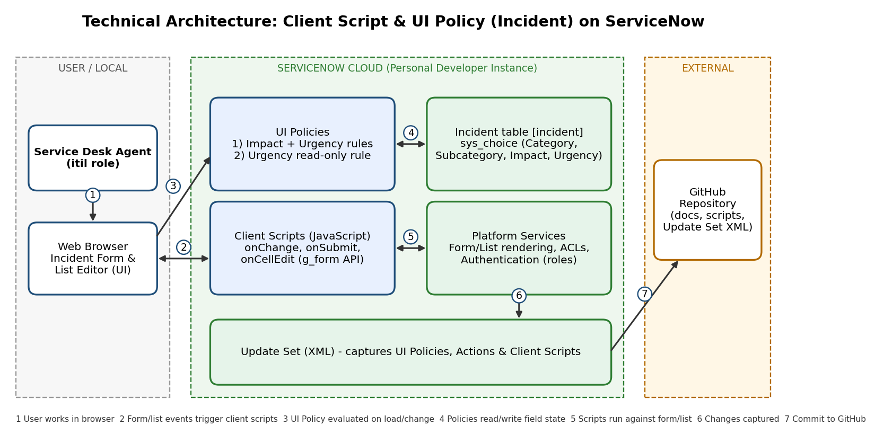
Table-1 : Components & Technologies:
S.No | Component | Description | Technology
1. | User Interface | How the agent interacts with the application: Incident form and Incident list (list editor) in the browser | ServiceNow Platform UI (Next Experience / UI16 forms and lists), HTML / CSS rendered by the platform
2. | Application Logic-1 | Declarative field control: mandatory / visible based on Impact and Urgency; Urgency read-only on Resolved / Closed | ServiceNow UI Policies and UI Policy Actions
3. | Application Logic-2 | Dynamic behavior: onChange (Category / Subcategory), onSubmit (validation), onCellEdit (list-editor validation) | Client Scripts in JavaScript using the GlideForm API (g_form)
4. | Application Logic-3 | Packaging and promotion of all configuration between instances | ServiceNow Update Sets (XML)
5. | Database | Incident records, choice lists (Category, Subcategory, Impact, Urgency) and configuration records (sys_ui_policy, sys_script_client) | ServiceNow relational database (Incident [incident], sys_choice tables)
6. | Cloud Database | Managed database service hosting the instance data | ServiceNow Now Platform instance database (Personal Developer Instance)
7. | File Storage | Attachments on incidents; documentation and Update Set XML stored in version control | ServiceNow attachments (sys_attachment); GitHub repository
8. | External API-1 | Not required; the solution runs entirely on the platform | N/A
9. | External API-2 | Source control for documentation, scripts and Update Set XML | GitHub
10. | Machine Learning Model | Not applicable to this project | N/A
11. | Infrastructure (Server / Cloud) | Application deployment on cloud | Local Server Configuration: none (browser-based access only)  Cloud Server Configuration: ServiceNow Personal Developer Instance (PDI) hosted on ServiceNow cloud
Table-2: Application Characteristics:
S.No | Characteristics | Description | Technology
1. | Open-Source Frameworks | No open-source framework is required; logic uses the platform's client APIs and standard JavaScript. Git is used for version control. | GlideForm API (g_form), JavaScript, Git / GitHub
2. | Security Implementations | Role-based access control and authenticated sessions; HTTPS/TLS; client-side rules treated as usability controls, with Business Rules / ACLs recommended for server-side enforcement | ServiceNow roles and ACLs, HTTPS/TLS, Business Rules (recommended)
3. | Scalable Architecture | Multi-tier platform (browser, application nodes, database); rules are declarative, condition-driven and reusable across incidents | ServiceNow Now Platform multi-tier architecture
4. | Availability | Client logic runs in the browser and follows the instance's availability. Production ServiceNow instances run on redundant cloud infrastructure; the PDI is for development and testing only | ServiceNow cloud hosting
5. | Performance | Logic executes in the browser with no server round trips; UI Policies preferred over scripts; no synchronous GlideRecord calls; isLoading guards prevent needless processing | UI Policies, asynchronous client patterns
References:
https://developer.servicenow.com
https://docs.servicenow.com
https://c4model.com/

